Marie Curie gender pay gap report April 2025

What is the gender pay gap?

The gender pay gap is a measure of workplace inequality, expressed in terms of a comparison between men’s and women’s average hourly rates of pay. It provides a framework within which gender pay gaps can be identified so that, both inside and outside of the workplace, employers and society at large can think constructively about why gender pay gaps exist and how we can all work to minimise them. The gender pay gap compares pay of all men and women across a workforce, without considering differences in job roles, experience, and qualifications.

The gender pay gap is not the same as ‘equal pay’ - paying men and women equally for performing identical roles - which has been a legal requirement since 1970.

The gender pay gap focuses on the following measures:
Gender representation | The number and proportion of men and women employed in the organisation. While we report our gender pay gap based on the government guidelines and comparison between men and women, we understand that this does not fully represent how all colleagues across the charity identify and our organisation’s commitment to supporting colleagues who are non-binary.
Mean total gender pay gap | This is best understood as the ‘true’ average of the hourly earnings of men and women – salaries for each gender are totalled and divided by the number of employees. The gap is measured by taking mean hourly rate for men minus mean hourly rate for women. Divide the result by the mean hourly rate for men, expressed as percentage.
Median total gender pay gap | The difference between the average hourly earnings of men and women – expressed through the salary that appears in the ‘middle’ for each gender. The gap is measured by taking median hourly rate for men minus median hourly rate for women. Divide the result by the median hourly rate for men, expressed as percentage.
Pay quartiles | All salaries are ranked from highest to lowest and divided into four evenly sized groups. The percentage of men and women in each group is reported.
Bonus pay gap | The difference between either gender, based on bonuses paid over the 12-month period before the snapshot date. As with Total Gender Pay Gap, this is reported on a median and mean.
Bonus proportion | The proportions of male and female employees who received bonus pay during the relevant period.

Marie Curie’s gender pay and bonus gap result
Our workforce: |  | Pay gap:
Women: | 85.4% (2,746) | Mean: | 11.9% (in favour of men)
Men: | 14.6% (468) | Median: | 6.5% (in favour of men)

Analysis and findings
We are pleased to report that our efforts since 2021 to close the gender pay gap have had a positive impact on our results. During this period, the mean gap has reduced from 17.6% to 11.9%, a reduction of 5.7%, and the median gap has seen a significant improvement, dropping from 14.6% in 2021 to 6.5% in 2025, a reduction of 8.1% indicating significant progress in pay equity.

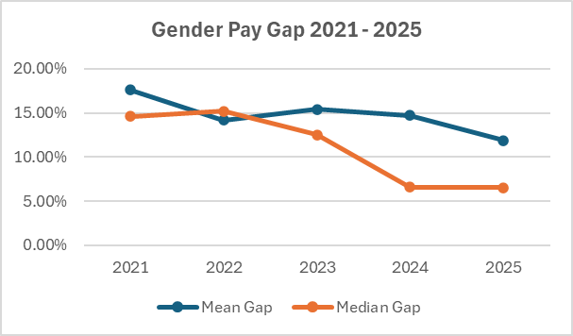

The sharp decline in the median gap between 2023 and 2024 proves meaningful progress in pay equity at mid-level roles. The key factor driving such a significant decrease in the gender pay gap is the introduction, in 2023, of a new and improved set of terms and conditions for employees in Clinical and Clinical Support roles, where 90% of the population is female. These improvements resulted in enhanced remuneration for colleagues in these roles.

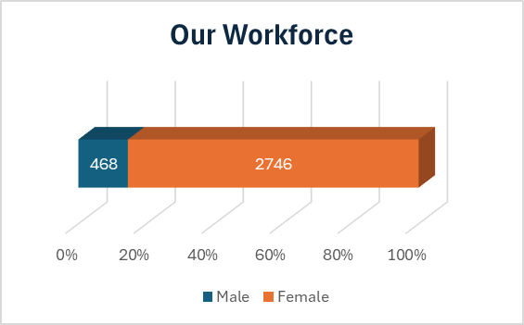
The overall downward trend reflects our commitment to addressing gender pay disparities. With the median gap now at 6.5%, the median measure provides a more accurate reflection of typical pay levels across Marie Curie, indicating improved balance.

We are pleased that the mean pay gap decreased by 2.8%. This measure remains higher than the median, as it is influenced by a small number of extreme values (very high or very low pay), and supports our further focus on the senior levels in the organisation. Additionally, our gender pay gap results are influenced by a combination of the following factors:

Percentage of women and men in each pay quartile:

The legislation requires us to present our workforce distribution by gender across four quartiles based on hourly pay.

Upper Quartile 4:  Women 79% (637); Men 21% (166)  Upper Middle Quartile 3:  Women 89% (713); Men 11% (90)  Lower Middle Quartile 2:  Women 88% (711); Men 12% (93)  Lower Quartile 1:  Women 85% (685); Men 15% (119) | 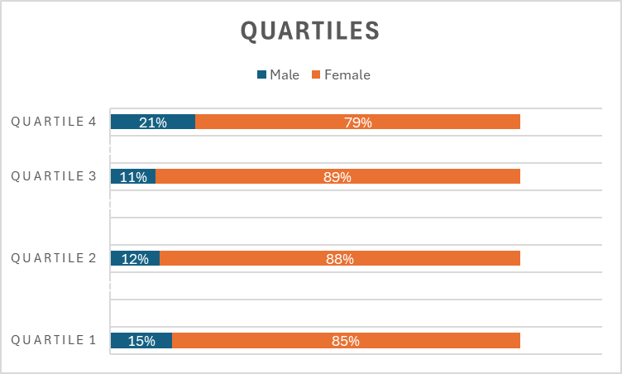

Over-representation in quartiles:
- Women are over-represented in all quartiles, especially in the lower ones.
- In the middle quartiles (quartiles 2 and 3), approximately 90% of employees are women, while only 10% are men.
- We have seen a 5% increase in male employees in the lower quartile (quartile 1) which is helping to address pay equity in lower-level roles (where pay ranges are smaller).
- The over-representation is connected to the nature of the roles across quartiles which research shows are still closely associated with women, including positions like Nurses, Healthcare Assistants, and Retail Assistants.

Proportion of men increases in the upper quartile:
- As we move up to the highest quartile (quartile 4), the proportion of men increases to 21% (same as April 2024).
- Although we have relatively few male employees overall, more of these men hold senior roles, which are associated to higher pay.

Our Bonus Gap and the portion of women and men receiving a bonus:

Bonus gap: |  | Portion of women and men receiving bonus:
Mean: | -7.5% (in favour of women) | Women: | 1.5% (40)
Median: | 0.0% | Men: | 0.6% (3)

As in previous years, our Bonus Pay Gap continues to be favourable for our female population. While Marie Curie has no bonus structure, the Recruitment Referral Scheme (“Refer a friend”) remuneration components fall under the ‘bonus’ definition of the gender pay gap reporting. While the payment is the same for all referrers, more female colleagues nominated more than one candidate, resulting in a -0.7% negative bonus pay gap mean (more favourable for women) and in a 0.0% median (no gap between male and female).

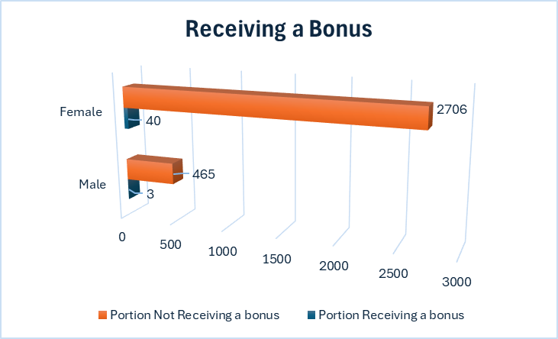

Our current and future efforts in closing the gap
During 2025, we continued with a series of initiatives (summarised below) which will, over time, positively impact our gender pay gap.

For colleagues on Marie Curie Clinical and Clinical Support Terms and Conditions (approximately 1,950 colleagues, of which approximately 92% were women), we continued implementing annual salary increases in alignment with similar roles in the NHS. The average annual salary increase for this population in 2025 has been 3.6%.

Flexible job design and inclusive practices - we promote and offer our people at every level the flexibility to establish both work-life balance and a working pattern that is right for them, and we maintain policies and practices that reflect the culture of inclusion we are striving for. Our workplace evolution initiative has seen more roles change from five days in the office to either flexible or fully remote roles.

Inclusive leadership development - We have strengthened inclusive leadership through targeted leadership development, refreshed EDI training, and tailored support for leaders, including LGBTQ+ Allies training. Embedding inclusion within our performance management approach means strengthening inclusive leadership behaviours, integrating wellbeing into regular performance discussions, and ensuring fairness in how performance is assessed. By introducing formal prompts for leaders to reflect on their wellbeing conversations and by providing clear guidance that signposts key inclusion and equity resources, we are supporting managers to hold high-quality, consistent, and unbiased reviews. This approach reinforces accountability, aligns with our broader ambition to build a culture of belonging, and helps ensure performance conversations are conducted with empathy, transparency, and equity. We are committed to addressing the Gender Pay Gap and are aware that it will take time for our efforts to be reflected in the reported figures.

Our Talent Acquisition team supports our ongoing reward efforts to reduce the gender pay gap by improving our fair hiring practices and processes, advising Hiring Managers on salary offers, promoting pay transparency in job adverts, and using better technology to assess the diversity and effectiveness our candidate attraction channels and recruitment.

